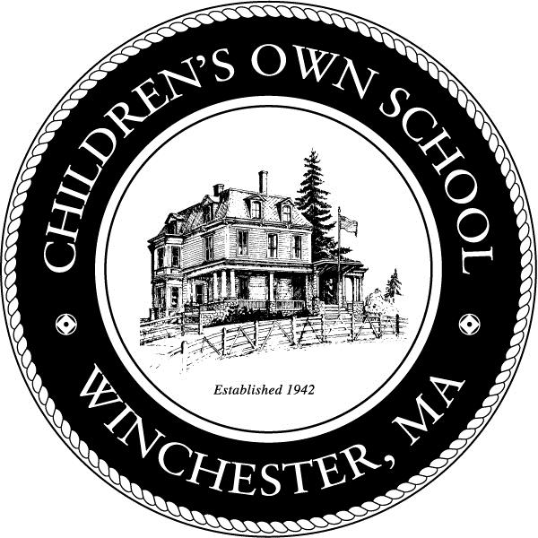 | Children's Own School  A Montessori Tradition since 1942  Application for Admission

Children who are 2.5 years old as of September 1st are considered eligible candidates for admission. Children between the ages of 2.5 and 2.9 years (as of September 1st) must be assessed developmentally ready for our program and agree to a developmental placement waiver by the Massachusetts Department of Early Education and Care.

Priority is given to siblings of current and former students who have completed the developmental cycle of our primary program, readiness for the program, and the parents’ commitment to Montessori education. In all cases, admission is determined after careful consideration as to the appropriate placement for the child. We strive to balance our classrooms by age and gender.

Applicant Information
Full Name:
 | Last | First | Preferred Name

Address:
 | Street Address | Apartment/Unit #

 | City | State | ZIP Code

Date of Birth:
Application for: | Montessori half day (8:30-12:00) |  | Montessori full day (8:30-2:30) |  | Full day plus Enrichment Program (8:30 – 4:30)
Are you interested in Early Care? |  | Yes |  | No

Parent/Guardian 1 |  | Parent/Guardian 2
Full Name |  | Full Name
Street Address |  | Street Address
City/State/Zip |  | City/State/Zip
Phone (best) |  | Phone (best)
Email |  | Email
Occupation/Title |  | Occupation/Title
Employer’s Name |  | Employer’s Name

Parents are: | Married/Living Together |  | Divorced |  | Separated |  | Single Parent

About Your Child and Family
Does your child currently attend school or a childcare program?
Current program (Name and Location)
What does your child like to do most at their current program?
Why do you want to leave that program?
Siblings
Name(s) and Ages(s) | School(s) currently attending

Which language(s) does the child speak at home?
If a language other than English is spoken at home, is your child: | Bilingual
 | English or other language is still emerging

How did you learn about Children’s Own School?
Why are you interested in a Montessori program for your child?

Please list any classes or activities your child does outside of school and/or the activities you like to do as a family.
Please share any additional information you would like us to know about your child or family, including any areas needing special attention, as well as your goals for your child at our school.

Registration fee of $50 is enclosed
Include a family picture with this application

It is understood when a child is accepted into the School, he/she is enrolled for the full school year. It is also understood that the Children’s Own School Montessori primary program is a developmental program that includes the kindergarten year and there is the expectation for a child to stay for the full developmental cycle. A deposit of one month’s tuition, applied to the first year tuition payment, is due on or before April 15th with the contract to reserve your child’s place. This amount is non-refundable without a 30-day notice of cancellation prior to July 1st.

Parent/guardian signature | date

Children’s Own School does not discriminate on the basis of race, cultural heritage, religion, sexual orientation, national and ethnic origin, marital status, political beliefs, or disability; and ensures to all the rights, privileges, programs, and activities generally accorded or made available to students at the School.
Office Use Only: Date Rec’d _____ Reg. Fee ______ Age 9/1_______ Parent Visit _____ Child Visit______

